PRESS RELEASE
Monitored Materials provides greater confidence when assessing recyclates
First Premium classification awarded to Schütz
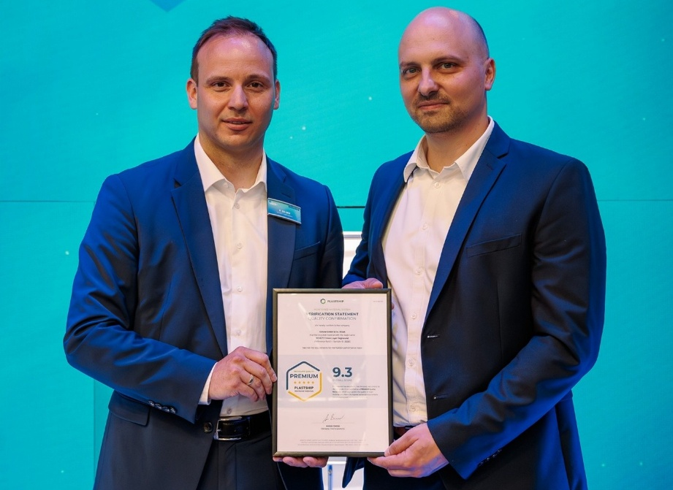
At interpack 2026, Schütz received the first assessment certificate based on the new plastship Monitored Materials system; right: Andreas Bastian, Managing Director of plastship GmbH, left: Patrick Bauer, Global Head of SHEQ Management and Technical Customer Service at Schütz GmbH & Co. KGaA. © plastship/Schütz
August 2026: The regranulate used by Schütz GmbH & Co. KGaA, Selters, for its Green Layer packaging is the first recycled plastic to be assessed under the new Monitored Materials system and awarded a quality certificate. Developed by plastship, the system provides data and thereby enables greater transparency and comparability for recyclates. On the occasion of interpack 2026, Andreas Bastian, Managing Director of plastship GmbH, presented this first certificate of its kind to Patrick Bauer, Global Head of SHEQ Management and Technical Customer Service at Schütz GmbH & Co. KGaA – one of the world’s leading manufacturers of industrial packaging. The Premium classification awarded confirms the high quality of this plastic, which is reprocessed in-house by Schütz into high-grade recyclate comparable with virgin material.

Robust basis for decision-making
The plastship Monitored Materials system provides a robust data basis for classifying recyclate qualities across companies, comparing them objectively and using them with confidence. It replaces the previously inconsistent structure of individual Technical Data Sheets (TDS) with a standardised, directly comparable language. Targeted testing transparently reflects the structural differences between virgin material and recyclates that arise from material streams, reprocessing processes and applications. The material qualities made tangible in this way through laboratory data and material flow information create greater confidence along the entire value chain.
“With Monitored Materials, we are creating a neutral data basis for the quality of plastic recyclates. It enables industry to make robust decisions and contributes to a shared understanding of recyclate quality – the foundation for increasing the use of high-quality recyclates.” – Andreas Bastian, Managing Director of plastship GmbH
Recyclate manufacturers can use plastship Monitored Materials to position their products precisely in the market. The plastics processing industry, in turn, gains a reliable and rapid basis for deciding on the use of these materials. The structured database significantly reduces the effort required to search for and qualify new materials, thereby saving both time and costs. Material identification in procurement as well as approval processes become less time-consuming, as validated datasets can be accessed directly. The assessment is transparent, with a score from 0 to 10 and classification into one of three quality segments: Premium, Plus or Proven.
The regranulate used by Schütz as the central layer in its extrusion blow-moulded Green Layer IBCs, drums and canisters achieved an outstanding score of 9.3 points in the assessment under the Monitored Materials system. The Premium classification certifies that, in terms of its use and processing properties, the material is comparable with the quality of virgin material. Within the growing database, which comprises 224 materials, it currently ranks in the top 5% of the European market.
Added value for subscribers through dynamic access to market data
Beyond the assessment itself, customers who have a material tested as a “Monitored Material”, as well as subscribers to an annual subscription, benefit from further advantages. The associated exclusive access to the relevant database serves as a central tool for strategic raw material management. It enables users to create dynamic quality rankings, compare recyclates with virgin reference materials or the overall market on a data-driven basis, and carry out direct material comparisons.
In addition to in-depth analyses such as the mapping of qualities to specific waste streams, the system also integrates market data on production capacities. This turns what would otherwise be a pure quality overview into a holistic management tool for the safe and predictable procurement of recyclates.
Data as the basis for compliance
Future regulations, such as the European Packaging and Packaging Waste Regulation (PPWR), will further increase the requirements placed on the use of recyclates and their technical documentation. To provide industry with a practical solution in this area, Monitored Materials form the foundation for future compliance documentation. The system is aligned with the EN 18065 standard on institutionalised data quality and turns recyclate information, which has often been difficult to substantiate to date, into reliable quality statements.
Certificate as proof of quality
The data determined for a “Monitored Material” is documented in the associated verification certificate. For recyclers, this serves as an objective, neutral and validated sales argument, while for plastics processors it also provides robust confirmation of quality for customers and brand owners. Both sides receive confirmation that achieving sustainability targets does not come at the expense of industrial material performance.
Further information on Monitored Materials can be found on the plastship website: https://plastship.com/en/monitored-materials
Über plastship GmbH
plastship GmbH, a subsidiary of RIGK GmbH, supports the plastics and packaging industry in sourcing, classifying, assessing and safely using recyclate qualities. The Monitored Materials system provides the structural basis for informed decisions in procurement, application and regulatory compliance (PPWR).

Further information:

plastship GmbH
Andreas Bastian, Founder & Managing Director
Auf der Lind 10
Germany- 65529 Waldems
Phone: +49 (0) 6126 589 80 10
bastian@plastship.com; www.plastship.com/en/
Editorial contact, specimen copies:
Konsens PR GmbH & Co. KG
Dr.-Ing. Jörg Wolters
Hans-Böckler-Straße 20
Germany-63811 Stockstadt
Phone: +49 (0) 60 27/99005-13
mail@konsens.de; www.konsens.de

This press information is available as a Word document, together with the image in print-ready resolution, for download at: www.rigk.de/en/worth-knowing/press

